NAME : Aditya Jajoo

CLASS : SYIT

ROLL NO : 17

#include <stdio.h>

#include <conio.h>

#define MAX 10

int deque[MAX];

int left = –1, right = –1;

void input_deque(void);

void output_deque(void);

void insert_left(void);

void insert_right(void);

void delete_left(void);

void delete_right(void);

void display(void);

int main()

{

int option;

clrscr();

printf("\n *****MAIN MENU*****");

printf("\n 1.Input restricted deque");

printf("\n 2.Output restricted deque");

printf("Enter your option : ");

scanf("%d",&option);

switch(option)

{

case 1:

input_deque();

break;

case 2:

output_deque();

break;

}

return 0;

}

void input_deque()

{

int option;

do

{

printf("\n INPUT RESTRICTED DEQUE");

printf("\n 1.Insert at right");

printf("\n 2.Delete from left");

printf("\n 3.Delete from right");

printf("\n 4.Display");

printf("\n 5.Quit");

printf("\n Enter your option : ");

scanf("%d",&option);

switch(option)

{

case 1:

insert_right();

break;

case 2:

delete_left();

break;

case 3:

delete_right();

break;

case 4:

display();

break;

}

}while(option!=5);

}

void output_deque()

{

int option;

do

{

printf("OUTPUT RESTRICTED DEQUE");

printf("\n 1.Insert at right");

printf("\n 2.Insert at left");

printf("\n 3.Delete from left");

printf("\n 4.Display");

printf("\n 5.Quit");

printf("\n Enter your option : ");

scanf("%d",&option);

switch(option)

{

case 1:

insert_right();

break;

case 2:

insert_left();

break;

case 3:

delete_left();

break;

case 4:

display();

break;

}

}while(option!=5);

}

void insert_right()

{

int val;

printf("\n Enter the value to be added:");

scanf("%d", &val);

if((left == 0 && right == MAX–1) || (left == right+1))

{

printf("\n OVERFLOW");

return;

}

if (left == –1) /* if queue is initially empty */

{

left = 0;

right = 0;

}

else

{

if(right == MAX–1) /*right is at last position of queue */

right = 0;

else

right = right+1;

}

deque[right] = val ;

}

void insert_left()

{

int val;

printf("\n Enter the value to be added:");

scanf("%d", &val);

if((left == 0 && right == MAX–1) || (left == right+1))

{

printf("\n Overflow");

return;

}

if (left == –1)/*If queue is initially empty*/

{

left = 0;

right = 0;

}

else

{

if(left == 0)

left=MAX–1;

else

left=left–1;

}

deque[left] = val;

}

void delete_left()

{

if (left == –1)

{

printf("\n UNDERFLOW");

return ;

}

printf("\n The deleted element is : %d", deque[left]);

if(left == right) /*Queue has only one element */

{

left = –1;

right = –1;

}

else

{

if(left == MAX–1)

left = 0;

else

left = left+1;

}

}

void delete_right()

{

if (left == –1)

{

printf("\n UNDERFLOW");

return ;

}

printf("\n The element deleted is : %d", deque[right]);

if(left == right) /*queue has only one element*/

{

left = –1;

right = –1;

}

else

{

if(right == 0)

right=MAX–1;

else

right=right–1;

}

}

void display()

{

int front = left, rear = right;

if(front == –1)

{

printf("\n QUEUE IS EMPTY");

return;

}

printf("\n The elements of the queue are : ");

if(front <= rear )

{

while(front <= rear)

{

printf("%d",deque[front]);

front++;

}

}

else

{

while(front <= MAX–1)

{

printf("%d", deque[front]);

front++;

}

front = 0;

while(front <= rear)

{

printf("%d",deque[front]);

front++;

}

}

printf("\n");

}

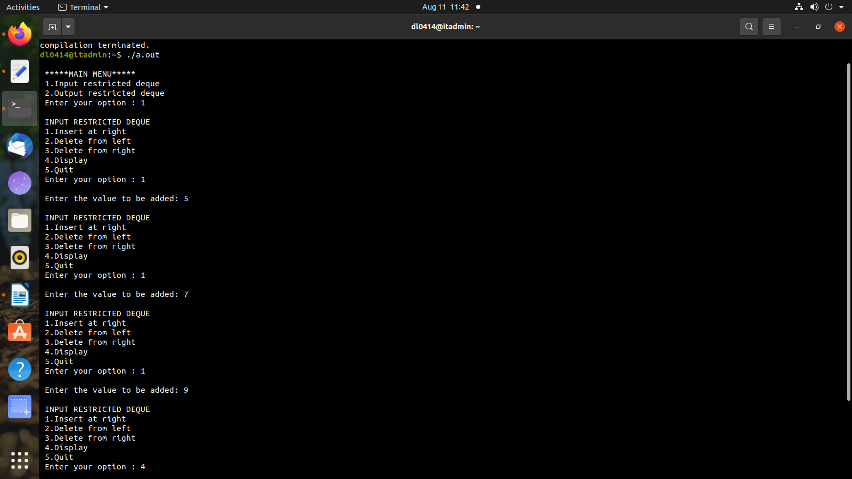OUTPUT :